DEVELOPMENT OF A WEB-BASED RECRUITMENT AND APPLICANT MANAGEMENT SYSTEM (R-AMS)
APPLICATION FOR XBP Global Company

A Thesis
Presented to the Faculty of the
College of Science
Technological University of the Philippines
Ayala Boulevard, Manila

By
Daryl T. Roallos

In Partial Fulfillment of the Requirements for the Degree
Bachelor of Science in Information Systems

December 20

ACKNOWLEDGEMENT

My deepest gratitude goes to the Lord, whose presence, grace, and guidance have sustained me throughout my life, career, and academic pursuit. In my weakest moments, He gave me strength; in my confusion, He gave me wisdom. Every step of this journey has been possible only through Him.
To my family, my fiancée Kim, my co-workers, managers, AVP and Australian Clients who have supported me from day one and inspired me to pursue my dream of earning a bachelor’s degree I would like to express my sincere appreciation for your love, support, and encouragement. Your belief in me kept me moving forward, even during the most challenging times.
My heartfelt appreciation also goes to all my professors and panel members—Professor Dolores Montesines, Professor Peragrino Amador, Professor Fernando Renegado, Professor Edward Cruz, Professor Ariel Tomagan, and Professor Julius Sareno—for generously sharing their expertise, wisdom, and patience.
To my capstone adviser, Professor May Garcia, thank you for your invaluable guidance, dedication, and support. Your insightful feedback, patience, and words of encouragement play a crucial role in shaping this study and helping me overcome every challenge along the way.
I would also like to express my profound gratitude to Dr. Kevien Cabarrubias-Dela Cruz, Ph.D., Director of the Expanded Tertiary Education, Equivalency and Accreditation Program (ETEEAP) of the Technological University of the Philippines, for accommodating me and granting me the opportunity to pursue my studies, complete my academic journey, and fulfill my lifelong dream of graduating. It has been an honor to be part of this institution, and I am grateful for the program’s commitment to excellence that helped me reach this milestone.

Table of Contents
DEVELOPMENT OF A WEB-BASED RECRUITMENT AND APPLICANT MANAGEMENT SYSTEM 1
ACKNOWLEDGEMENT 1
CHAPTER 1 1
INTRODUCTION 1
Background of the Study 1
Objectives of the Study 3
Technologies Included: 4
Scope and Limitations of the Study 5
CHAPTER 2 7
CONCEPTUAL FRAMEWORK 7
Review of Related Literature 7
Digital Transformation in Human Resource Management 7
Pre-Screening Through Skills-Based Application Forms 9
HR Analytics and Data-Driven Recruitment 9
Challenges and Enablers of HR Digital Systems 11
Application Standard Requirements 12
Tools and Technologies for Developing the System 12
Software Testing Framework 15
ISO/IEC 25010 Software Quality Evaluation 16
Conceptual Model of the Study 17
Input 17
Process 18
Output 19
Operational Definition of Terms 20
CHAPTER 3 22
METHODOLOGY 22
Project Design 22
System Architecture Diagram 22
Software Design 24
Database Design 25
System architecture 27
Project Development 36
Evaluation Procedure 43

CHAPTER 1

INTRODUCTION

Background of the Study
Technology changes every year, and we cannot control its pace. These changes, including AI, affect every industry differently, so adapting is necessary to keep up. In my experience working in the BPO industry for 15 years, I have seen our HR departments often use manual (Figure 1), spreadsheet-based methods to record, monitor, and evaluate applicants. Before the new system, recruitment relied on multiple Excel and Google Sheets files managed by different HR staff, which sometimes caused inconsistent data entry, duplicate records, and made it hard to combine information for reports and decisions. When applicants came on-site, they filled out paper forms, and HR staff re-encoded them. Applicants from online sources like Indeed or job ads were also processed through recruitment email inboxes, and HR staff had to manually enter their data into tracking files.
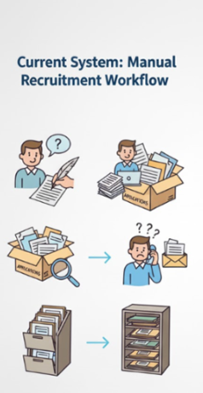
Figure 1. Current manual system on our HR dept

This manual and scattered process led to several problems. Without a central database, it was hard to keep applicant information accurate, consistent, and secure. The high number of applicants in the BPO industry also caused delays in screening and scheduling interviews. Because there was no single monitoring system, HR could have difficulty in tracking applicant status, interviews, deployment, recruiters' performance in real time. As a result, HR managers struggled to create reports and spot hiring trends needed to improve efficiency. Recent findings demonstrate that digital HRM systems significantly increase HR efficiency in organizations undergoing digital transformation (Mahmoud et al., 2025), which further supports the need to replace manual recruitment workflows with automated, data-driven systems.

There is now a greater need for a streamlined, data-driven HR recruitment process. Recent research also highlights that digital HR transformation goes beyond simple digitization of tasks—it requires structural changes, modernized workflows, and enhanced information systems to support more efficient decision-making (Bansal, 2023). These emerging trends show that many organizations are now adopting role-based access systems, interactive dashboards, and secure web applications to increase accountability, transparency, and efficiency in HR operations. (Figure 2)
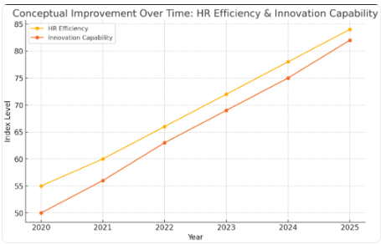
Figure 2. (Conceptual improvement over time using digital application)

To address these challenges, this research set out to design and build a Two-Tier Web-Based Recruitment and Applicant Management System (R-AMS) with an Applicant User Web Form and an HR Recruitment Management System, both connected to a centralized database. The intention of the project is to create an innovative, secure, and efficient recruitment tool that reduces manual work, keeps data accurate, and helps HR staff make timely, informed decisions. The study also sought to qualitatively understand user experience, workflow improvements, and system feasibility within an actual HR operational environment.

Objectives of the Study
The general objective of this study is to design and develop a secure, database-driven, two-application Web-Based Recruitment and Applicant Management System that centralizes applicant data collection, and enables HR personnel to manage, update, extract, and visualize recruitment information within a role-based access environment using modern web technologies.

Specifically, this study aims to:
- Develop an Applicant User Web Form, using HTML, CSS, JavaScript, PHP and TailwindCSS, that captures and stores applicant information directly in the company’s local database server.
- Build a secure Login Form using PHP, MySQL, and session-based authentication, ensuring controlled access based on assigned user roles.
- Develop an HR Management System using JavaScript , PHP REST APIs, and MySQL with full CRUD functionalities for applicant records, interview schedules, and recruitment statuses.
- Integrate Role-Based Access Control (RBAC) using PHP session handling to authenticate users and redirect authorized HR personnel to the appropriate dashboard view.
- Implement a Bulk Upload Module using PapaParse.js and Fetch API to validate and upload CSV files, allowing HR users to import multiple applicant records efficiently.
- Design and develop a recruitment analytics dashboard using Chart.js, Litepicker, TailwindCSS, and JavaScript to visualize KPIs such as applicant volume, hiring trends, time-to-hire, and recruiter performance.
- Incorporate data extraction features, including the ability to export applicant records, filtered datasets, and system logs to CSV using JavaScript and PHP.
- Implement an appointment scheduling and notification module using PHP, JavaScript, and MySQL, prompting the HR personnel for any upcoming activities.
- Integrate a system logs module using PHP and MySQL, recording CRUD actions, login attempts, bulk uploads for accountability and audit compliance.
- Integrate a search mechanism for specific fields and multiple actions like select all using Javascript and PHP.
- Apply strong security measures, including SQL injection protection, encrypted password hashing (e.g., password_hash), secure session management, and role-based access restrictions.
- Ensure that all recruitment data, records, and system logs are stored exclusively within the company’s local server and internal intranet environment, maintaining confidentiality and security.
- Test and refine the system using tools such as browser DevTools, PHP debugging tools, and user feedback, based on ISO/IEC 25010 software quality characteristics (usability, performance, reliability, and maintainability).
- Evaluate user acceptability, usability, system efficiency, and reliability through testing with HR personnel to determine the system’s overall effectiveness in supporting real-world recruitment operations.

Technologies Included:
Category | Technologies / Tools
Frontend | HTML, CSS, TailwindCSS, JavaScript, Chart.js, Litepicker, PapaParse.js
Backend | PHP, MySQL, Secure sessions (session_start), Password hashing
Communication | Fetch API, JSON-based REST responses
Deployment Environment | Local intranet, Company server, Role-based access

Scope and Limitations of the Study
The study focused on the design and development of a two-tier, web-based recruitment and applicant management system designed for use by the company's Human Resources (HR) department. The system comprises an Applicant User Web Form (Tier 1) and an HR Recruitment Management System (Tier 2), which work together to streamline and modernize the organization’s recruitment workflow. The first tier works as the primary data-entry interface used by HR front desk staff or designated applicant terminals. It captures applicant information and stores the records in a centralized MySQL database(Xeon Server). The second tier, accessible exclusively to authorized HR staff through a Role-Based Access Control (RBAC) mechanism, enables efficient management of recruitment data through features such as CRUD operations, pre-screening, status updates, archiving, dashboards with charts and recruiter performance summaries, bulk upload processing, CSV validation and system activity logs.
The application will be developed using modern technologies to ensure reliability, scalability and a user-friendly experience. These include JavaScript for interactive components, PHP API endpoints for backend logic and data processing, and MySQL for centralized storage. To improve UI/UX and analytics capabilities, the system integrates Chart.js, Litepicker, PapaParse, and TailwindCSS. The entire system will operate only within the company’s intranet environment. Dashboard analytics display summaries based on stored internal records, system logs provide traceability of actions performed, and the bulk upload functionality strictly accepts CSV templates that follow the established data schema. Stakeholders covered in this study include HR staff, HR managers, applicants (through indirect interaction with the input interface), information systems developers, and future researchers focusing on HRIS or web-based recruitment systems.
Despite its extensive functionality, the system has several limitations. Its accessibility is restricted to the internal company network, meaning it cannot be accessed remotely or outside the intranet. The system does not include AI-driven automation, such as résumé scanning, applicant ranking, or automated decision-making, as these features fall outside the scope of the current development phase. Notification features will only implemented to dashboard itself to alert the staff for any scheduled/upcoming events, or manual follow-ups, particularly when third-party integrations are unavailable. The system is intended for use on desktop/laptop or workstation that is connected to company Intranet. Therefore, compatibility and usability testing will only be conducted on browser within the intranet network. Additionally, the system’s overall performance is tied to the company’s existing server capacity(Xeon Server) and network stability. Although the evaluation of the system is guided by the ISO/IEC 25010 quality framework—specifically assessing usability, reliability, performance efficiency, and maintainability. Furthermore, the project is limited to recruitment-related functions and does not include post-employment modules such as payroll, employee performance evaluation, or promotion tracking.
The study is significant to several key stakeholders. For the HR Department, the system enhances operational efficiency through streamlined processing, centralized data storage, and real-time analytics. HR Managers gain improved monitoring capabilities, data-driven decisions regarding recruitment. Applicants benefit from faster and more organized handling of their information. For company management, the system supports digital modernization efforts and strengthens alignment with data protection and security standards. The project also contributes to the field of information systems, offering information systems developers a practical reference model for secure, role-based HR applications. Lastly, future researchers may use this study as a resource for further explorations involving HRIS development, web-based recruitment systems, analytics applications, and software evaluation frameworks.

CHAPTER 2

CONCEPTUAL FRAMEWORK
This chapter presents the review of related literature and studies that provide the theoretical, conceptual, and empirical foundation of the proposed Recruitment and Applicant Management System (R-AMS). It discusses relevant concepts on digital HR transformation, HR analytics, data-driven recruitment, and digital system adoption. The chapter also outlines the conceptual model, the tools and technologies used in system development, the software testing framework, and the operational definition of terms.

Review of Related Literature

Digital Transformation in Human Resource Management
Digital Transformation in Human Resource Management refers to the integration of digital technologies, automated workflows, data-driven tools, and modernized infrastructures into HR operations to replace slow, fragmented, and manual processes. It represents a strategic shift in how HR teams manage data, interact with applicants, and execute recruitment decisions. As Bansal (2023) explains in A Study of Human Resource Digital Transformation (HRDT), HR digitalization involves the modernization of infrastructure, workflow enhancement, and organizational adaptation to digital systems. HR departments that transition from paper-based or spreadsheet-dependent processes to digital environments experience significant improvements in data accuracy, reduction of redundancy, faster processing times, and greater interdepartmental coordination.
Mahmoud, Ali, Alrifae, and Abu Eitah (2025), in their article The Impact of Digital HRM System and Digital Transformation on HR Efficiency, emphasize that digital HR systems improve organizational agility by automating repetitive tasks, centralizing applicant data, and enabling analytic tools. Their findings highlight the importance of dashboards, real-time summaries, and systematic interfaces in minimizing human error and increasing operational accuracy. Understanding these concepts formed part of the researcher’s knowledge requirements, as familiarity with digital HRM frameworks was essential in designing modules for the Recruitment and Applicant Management System (R-AMS). The researcher needed to study recruitment workflows, common bottlenecks in traditional HR practices, and the theoretical foundation behind automation to ensure that R-AMS accurately reflects modern HR operations.
Digital transformation literature also reinforces the importance of technical competencies. To implement the digital processes highlighted by these studies, the researcher/developer had to learn software development tools and technologies such as PHP for backend data processing, JavaScript for interactive dashboards and interface behavior, MySQL for centralized storage, and TailwindCSS for responsive UI design. These technologies operationalize the digital concepts described in HR transformation research. For instance, dashboards recommended by Mahmoud et al. (2025) were translated into real system components through Chart.js, while centralized data storage was achieved through relational database structures in MySQL. The bulk upload improvement seen in digital HR systems required the implementation of PapaParse.js, enabling the system to handle large volumes of applicant data consistent with real-world recruitment needs.
The insights from Setyawati et al. (2021) in Web-Based Management Information System for Services further underline the significance of centralization and reliable data architecture. Their findings show that digital platforms improve visibility, accuracy, and responsiveness—key performance elements examined under ISO/IEC 25010, particularly the characteristics of functional suitability, performance efficiency, and reliability. Understanding these quality attributes was part of the researcher’s preparation, ensuring that the R-AMS would meet accepted standards of software quality. The emphasis on real-time analytics and responsive interfaces aligns with ISO 25010’s requirements for usability, operability, and user assistance, supporting an HR-friendly system experience.
As companies expand their workforce and applicant pools, the demand for systems capable of managing large datasets becomes increasingly critical. Digital HRM systems address this challenge by consolidating applicant records, generating real-time summaries, and accelerating decision cycles—capabilities that are indispensable in time-sensitive recruitment environments. The proposed R-AMS responds to these digital modernization trends by integrating secure data storage, real-time analytics panels, guided workflows, and role-based access management. These features reflect both the conceptual foundations presented in HR digital transformation literature and the practical software engineering principles required for building a reliable and scalable HR system.
Through the lens of existing research, digital transformation is not merely a technical enhancement but a strategic organizational direction. It requires an understanding of HR processes, technical development skills, and awareness of software quality standards. Thus, the development of R-AMS is grounded in this broader movement toward technologically enabled recruitment workflows—prioritizing automation, centralized control, analytics-supported decision-making, and compliance with software quality.

Pre-Screening Through Skills-Based Application Forms
Pre-screening is an initial filtering stage in recruitment where applicants are evaluated based on basic qualifications and skills before advancing to interviews. This process uses structured form fields such as skill checklists, education, and relevant experience to determine whether an applicant meets the minimum job requirements. According to a 2021 study on Recruitment and Selection: The Relationship between Recruitment and Selection with Organizational Performance, organizations utilizing application form criteria such as qualifications, certifications, and skills achieve better alignment between applicant competencies and job needs. This reinforces the relevance of a simple, skills-based pre-screening method in improving recruitment effectiveness.
The integration of pre-screening within the R-AMS allows the system to automatically categorize applicants as “Qualified,” “Borderline,” or “Not Qualified” based on predefined skill requirements. This automated segregation of applicants enables HR personnel to quickly focus on those who match specific job criteria, reducing manual workload and time spent reviewing unqualified applicants. However, pre-screening does not replace traditional recruitment methods such as interviews and detailed assessments. Instead, it acts as a supportive tool that improves efficiency in managing large applicant volumes and ensures that further evaluation is reserved for those with appropriate baseline skills.
By structuring applicant data into sortable and filterable fields, the pre-screening feature enhances usability, reliability, and functional suitability as outlined in the ISO/IEC 25010 quality model. Through this approach, the R-AMS ensures that recruitment decisions remain fair and evidence-based while still preserving the essential human judgment required in the final hiring stages.

HR Analytics and Data-Driven Recruitment
Human Resource Analytics, also known as talent analytics or people analytics, refers to examination, and interpretation of workforce-related data to support strategic HR decision-making. Within recruitment, HR analytics involves evaluating hiring patterns, forecast staffing needs, assess recruitment sources, and measure recruiter performance. As described by Krishna and Verma (2025) in Human Resource Analytics in the Digital Transformation Era, analytics has become a central component of modern HR functions because it transforms raw, unstructured data into actionable insights. These insights guide HR teams in monitoring applicant trends, identifying skill gaps, and optimizing recruitment processes based on quantifiable evidence rather than intuition or manual observation.
A strong understanding of HR analytics frameworks formed part of the researcher’s knowledge requirements, as it was essential to analyze the relationship between applicant flow, recruitment timelines, and performance metrics. The researcher had to explore how analytics algorithms interpret HR data, the role of accurate data encoding, and the importance of structured datasets for meaningful visualization. Understanding the recruitment lifecycle—from applicant entry to evaluation and confirmation—was also necessary to design analytics components that reflect actual HR workflows. Without this conceptual knowledge, it would not be possible to build dashboards or KPI indicators that align with real-life recruitment structures.
Data-driven recruitment provides HR departments with a clearer understanding of processing times, bottlenecks, and source effectiveness. Ruiz, Marín, and Benítez (2024), in their work Digital Human Resource Strategy: Conceptualization and Empirical Evidence, emphasize that organizations leveraging HR analytics achieve improved operational performance because analytics make HR functions more measurable, and transparent, and outcome-based. Their findings show that systems equipped with real-time metrics significantly enhance HR teams’ ability to allocate resources, manage applicant volume, and evaluate recruiter productivity.
To transform these analytical concepts into system features, the researcher/developer needed to master specific software technologies. The creation of dashboards required proficiency in Chart.js, a JavaScript visualization library used to generate interactive KPI graphics. Knowledge of JavaScript and the Fetch API was required to retrieve filtered datasets from the backend, while Litepicker enabled flexible date-range filtering for time-based analyses. Proficiency in MySQL was necessary to construct optimized queries that return aggregated data, such as counts per status or recruiter performance metrics. These technologies were essential to implement the data-driven recruitment practices described in the academic literature.
The integration of HR analytics into R-AMS also aligns with the ISO/IEC 25010 software quality framework. The use of dashboards supports the characteristic of functional suitability, ensuring the system provides the analytical functions HR personnel require. Real-time updates and interactive charts contribute to performance efficiency and usability, as users can access well-structured information without delays or complexity. Accurate data visualization further enhances reliability by reducing misinterpretation and providing consistent output. By grounding the analytics features of R-AMS in ISO 25010 principles, the system ensures accuracy, relevance, and operational value for HR end-users.
The proposed R-AMS fully integrates these data-driven recruitment principles through its use of analytics dashboards, KPI cards, and trend visualizations. Chart.js components present applicant count, Deployment progress, and platform utilization, while filtering tools allow HR personnel to refine data by date range or recruitment stage. These features provide immediate insight into recruitment performance and workload distribution, supporting evidence-based decision-making. Through this alignment with HR analytics literature, the R-AMS functions as a modern tool designed for organizational efficiency, accuracy, and strategic HR management.

Challenges and Enablers of HR Digital Systems
Digital HR systems offer significant advantages, yet their effectiveness depends on user readiness, system usability, and organizational support. Rahadi et al. (2025),Digital HR tools implementation in smart workspaces, emphasize that digital tools often fail when employees lack proper training or when workplace culture does not fully embrace technological change. Understanding these adoption factors formed part of the researcher’s knowledge requirements, particularly in learning how HR personnel interact with technology, what interface challenges they encounter, and how system design can reduce barriers to adoption.
Bratamanggala et al. (2023), Digital transformation in human resource management: A systematic literature review, in their systematic review of HR digital transformation, highlighted that organizations relying on manual spreadsheets commonly encounter data inconsistencies, redundant entries, and reporting difficulties. These limitations reinforced the researcher’s need to understand centralized database structures, data accuracy principles, and workflow optimization to ensure that the R-AMS resolves the inefficiencies described in the literature.
Addressing these challenges also required the researcher to study specific software and technical tools essential for building a stable digital HR system. Backend technologies such as PHP and MySQL were needed to maintain consistent and secure records, while JavaScript and TailwindCSS supported the development of an intuitive and user-friendly interface. The inclusion of role-based access control, activity logs, and validation functions was guided by the need to reduce the common data errors and inconsistencies noted in previous studies.
These literature findings directly align with the ISO/IEC 25010 software quality model. Issues related to user adoption reflect usability attributes such as learnability and operability, while data inconsistency problems relate to reliability and functional suitability. Understanding these quality characteristics helped the researcher integrate features that support accuracy, stability, and user protection.
With this, the R-AMS was designed with simplified navigation, secure role-based access, centralized data storage, and real-time dashboards. These features address the major challenges identified in the literature—such as fragmented records and limited reporting—making the system a practical, user-centered solution for modern HR digital environments.

Application Standard Requirements
The R-AMS is a web-based HR system accessible through standard browsers such as Chrome or Edge. It works perfectly on desktops and laptops across workstations.
As an intranet-based system, it operates within the company’s secure local network, ensuring that applicant data remains internal, protected, and compliant with institutional privacy policies.

Tools and Technologies for Developing the System
Visual Studio Code (VS Code) is a lightweight and powerful source-code editor used in developing the R-AMS. It operates efficiently across Windows-based workstations and provides built-in support for JavaScript, PHP, HTML, and CSS. As a modern development environment, Visual Studio Code enables software developers to write, debug, and manage source code effectively due to its extensibility and integrated tools.
Visual Studio Code has different uses and benefits such as:
● Collaborate and code remotely
● Fix errors as you code
● Compare changes in your code
● Manage source control through built-in Git integration
● Extend functionalities through plugins for debugging and formatting
PHP (Hypertext Preprocessor) is an open-source, server-side scripting language used to develop the backend APIs, authentication services, and data processing components of the system. Originally known as “personal home page,” it is now recognized as a recursive acronym for “hypertext preprocessor.” PHP allows the system to communicate with the MySQL database, process form inputs, handle authentication logic, and produce dynamic content rendered on the web interface.
Aspects of PHP set it apart from other languages:
a. Scripting Language: PHP is interpreted at runtime without the need for compilation.
b. Server-Side Processing: PHP scripts run on a web server and return the result to the browser as HTML.
c. Open-Source: Freely available and widely supported by the programming community.
d. Object-Oriented: Supports OOP concepts for reusable and modular code.
e. Fast Performance: Memory-efficient and capable of handling heavy workloads; benchmarks show it can perform significantly faster than several interpreted languages.
f. Simple Syntax: Easy to learn, making it accessible for building applications of varying complexity.
g. Well Supported: Compatible with major databases (MySQL, SQLite, ODBC) and web servers (Apache, IIS), and supported by frameworks such as Laravel and CodeIgniter.
PHP is also a loosely typed language, allowing flexible variable declarations using eight primary data types. This flexibility enables developers to build dynamic and scalable backend logic for the system.
JavaScript is the primary language used for front-end logic in the R-AMS. It makes the system interactive and responsive by modifying webpage content in real time based on user actions. JavaScript enhances the dynamic behavior of the interface through DOM manipulation, enabling changes such as table updates, form validation, modal windows, and interactive dashboard elements.
JavaScript enables several essential client-side functions:
● Dynamic DOM manipulation for realtime UI updates
● Communication with backend APIs via the Fetch API
● Rendering of charts, summaries, tables, and modals
● Handling of data validation and error prompts
● Processing and previewing of bulk upload files
TailwindCSS is a utility-first CSS framework used to style and layout the system interface. It provides predefined classes for spacing, colors, typography, shadows, grids, and responsiveness. Unlike traditional CSS, TailwindCSS allows styling directly within the HTML structure, enabling faster development and consistent design across modules. Its responsive utilities ensure the system displays properly across various workstations used by HR personnel.
PapaParse.js is a JavaScript library integrated into the bulk-upload feature of the R-AMS. It enables fast and accurate parsing of CSV files directly within the browser, allowing HR staff to validate data before saving it into the database. PapaParse supports error detection such as incorrect formats, missing fields, or invalid structures—preventing corrupted data from being uploaded.
PapaParse provides the following key functions:
● Parsing large CSV files with high performance
● Detecting and reporting formatting errors
● Previewing parsed applicant data
● Validating fields based on the system’s data schema
Chart.js is a JavaScript library used to generate the system’s analytics and dashboard visualizations. It supports interactive charts such as bar graphs, line charts, and pie charts, which help HR personnel interpret applicant flow, recruitment trends, and performance indicators.
Chart.js is used in the system to:
● Display recruitment KPIs
● Generate visual summaries of applicant status
● Monitor recruiter productivity
● Provide real-time graphical analytics
Litepicker is a lightweight JavaScript date-range picker integrated into the dashboard filtering module. It simplifies the selection of dates and supports various formats, allowing HR users to filter reports or analytics based on specific time periods.
Litepicker helps the system by enabling:
● Easy date and range selection
● Smoother filtering of dashboard views
● Accurate retrieval of time-based recruitment data
The system is hosted on an Intel Xeon server running a MySQL database. MySQL is a relational, SQL-based database management system storing all applicant profiles, logs, recruiter data, schedules, and system-generated activities. The Intel Xeon server provides stability and processing strength required for handling large volumes of HR records, ensuring that data remains accurate, secure, and consistently retrievable.
MySQL offers the following advantages:
● Fast query execution for large datasets
● Transaction-safe storage for sensitive information
● Scalability for growing recruitment operations
● Strong integration with PHP APIs and backend logic

Software Testing Framework
Software testing ensures that the system meets functional requirements and delivers the expected performance. Testing includes:
Type of Test | Description | Purpose / Expected Outcome | Modules Covered
Functional Testing | Verifies that each system function operates according to specifications. | Ensure all features perform correctly based on requirements. | Login, RBAC, Applicant Form, CRUD, Bulk Upload, Dashboard Filters, Logs, Export CSV
Usability Testing | Assesses user experience, interface clarity, and ease of navigation. | Ensure system is HR-friendly, and easy to learn. | Dashboard UI, Applicant Tables, Modals, Navigation Bar, Forms
Performance Testing | Measures system behavior under specific workloads (speed, responsiveness). | Ensure fast loading times and efficient handling of large data sets. | Bulk Upload (CSV), Dashboard Charts, Search & Filters
Security Testing | Evaluates system protection mechanisms against threats and unauthorized access. | Prevent SQL injection, unauthorized entry, and data breaches. | Login Module, RBAC, Password Hashing, Session Security
Compatibility Testing | Ensures the system works across various browsers and devices. | Verify that layout and functions remain consistent. | Desktop (Chrome, Firefox, Edge)
Integration Testing | Tests interactions between modules to ensure smooth data flow. | Ensure backend APIs and frontend JavaScript work together correctly. | PHP REST AP - JavaScript Modules, Database Connections
Database Testing | Checks data integrity, storage accuracy, queries, and constraints. | Ensure correct database operations and prevention of duplicate or corrupted records. | Applicant Table, Logs Table, Status Table, Recruiter Table
Error Handling & Validation Testing | Verifies system responses to invalid inputs, errors, or failures. | Ensure meaningful error messages and prevention of system crashes. | Forms, Upload Validation (PapaParse), Edit Modals
Regression Testing | Re-checks existing features after updates are made. | Ensure new changes do not break previously working functionalities. | All modules after revisions
User Acceptance Testing (UAT) | Conducted with HR personnel to assess satisfaction and acceptability. | Confirm system meets HR needs, is usable, and ready for deployment. | Full System — HR Staff & HR Manager workflows
Testing outputs guide refinement before final deployment.

ISO/IEC 25010 Software Quality Evaluation
ISO/IEC 25010 defines eight software quality characteristics used in evaluating the R-AMS:
Quality Characteristic | Sub-Characteristics | Description (Applied to the Proposed R-AMS)
Functional Suitability | - Functional Completeness  - Functional Correctness  - Functional Appropriateness | Ensures the system provides all required recruitment functions (login, RBAC, CRUD, bulk upload, logs, dashboards), performs them accurately, and supports HR tasks efficiently.
Performance Efficiency | - Time Behaviour  - Resource Utilization  - Capacity | Measures loading speed, dashboard responsiveness, and the ability to process large applicant datasets (especially during bulk upload).
Compatibility | - Co-existence  - Interoperability | Ensures R-AMS works within the company intranet and interacts smoothly with browsers and local servers.
Interaction Capability (Usability) | - Appropriateness Recognizability  - Learnability  - Operability  - User Error Protection  - User Engagement  - User Assistance  - Self-Descriptiveness | Evaluates ease of use for HR personnel, clarity of user interface, intuitive navigation, and prevention of encoding or selection errors.
Reliability | - Faultlessness  - Availability  - Fault Tolerance  - Recoverability | Measures the stability of the system, minimal downtime, correct handling of invalid inputs, and recovery functions (e.g., logs, backups).
Security | - Confidentiality  - Integrity  - Non-repudiation  - Accountability  - Authenticity  - Resistance | Ensures data protection through RBAC, hashed passwords, secure sessions, audit logs, and protected database operations.
Maintainability | - Modularity  - Reusability  - Analysability  - Modifiability  - Testability | Evaluates how easily developers can update modules (e.g., HR dashboard, bulk upload), analyze issues, and enhance functionalities.
Flexibility (Portability/Scalability) | - Adaptability  - Scalability  - Installability  - Replaceability | Ensures the system can scale with HR recruitment volume, adapt to more users, and be deployed across different workstations.
Safety | - Operational Constraint  - Risk Identification  - Fail Safe  - Hazard Warning  - Safe Integration | Ensures the system prevents data loss, identifies risky operations (e.g., deletion), and protects system integrity during failed uploads or crashes.
This model guides the testing and acceptance evaluation of the system.

Conceptual Model of the Study
The conceptual model provides the structural foundation for the development of the Recruitment and Applicant Management System (R-AMS). Following the Input–Process–Output (IPO) framework, it outlines the essential elements required to conceptualize, design, implement, and evaluate the system.

Input
The input phase includes the necessary data elements, user credentials, and operational requirements that enable the entire system to function effectively. These inputs represent the information collected, processed, and stored within the R-AMS:
• Applicant data – personal details.
• CSV files for bulk upload – standardized templates used for mass encoding of applicant records.
• HR login credentials – authentication inputs required for secure access to system modules.
• Recruitment activity logs – traceable system events that record user actions, updates, and workflow transitions.
These inputs are supported by previously established knowledge requirements involving HRM concepts, recruitment workflows, data privacy practices, and ISO/IEC 25010 evaluation principles. They are further reinforced by software requirements such as PHP, MySQL, JavaScript, and added libraries (Chart.js, PapaParse, Litepicker), ensuring that the system accurately processes and protects all HR-related data.

Process
The process phase represents the system modules and backend operations that transform inputs into meaningful and actionable outputs. This includes automated workflows, data processing, analytics generation, and authentication procedures. The major system modules involved in the process phase are the following:
• Login and Role-Based Access Control (RBAC) – handles authentication and ensures that authorized personnel can access appropriate features.
• Applicant Form Module – captures applicant information through structured input fields.
• Bulk Upload Module – processes and validates CSV files for mass data entry using client-side parsing tools.
• CRUD Operations – supports creating, reading, updating, and archiving applicant records.
• Dashboard Analytics – generates recruitment metrics, status summaries, and performance indicators through interactive Chart.js components.
• Logs Module – documents system activity, updates, and important user interactions for audit and traceability.
• Notification Module – manages appointment reminders or system-generated updates.
• Pre-screening – small process that happens right after the application form is filled, and it feeds data (skills, score, status) into the HR dashboard for easy sorting.
• Extraction features – the user can extract a report based on what information they need.
• Security Features – includes validation mechanisms, hashed credentials, session management, and prevention of unauthorized access.
Throughout this phase, the system undergoes design, coding, integration, and continuous testing. ISO/IEC 25010 serves as the quality framework to evaluate usability, reliability, functional suitability, performance efficiency, and security.

Output
The output phase represents the measurable results and benefits delivered by the fully developed R-AMS. These outputs directly respond to the challenges identified in the literature and support HR operational improvements.
• Centralized applicant records – a unified repository for structured, accurate, and secure applicant data.
• Efficient recruitment workflow – streamlined processes that reduce manual handling and improve turnaround time.
• Real-time performance dashboards – data visualizations that support HR monitoring, decision-making, and workload analysis.
• Minimization of manual errors – reduced duplication, inconsistencies, and encoding mistakes through validation and automation.
• Improved HR decision-making – enhanced insights through analytics, status tracking, and recruitment trends.
These outputs reflect the system’s alignment with digital transformation practices and software quality standards, enabling HR departments to adopt a modernized and data-driven recruitment approach.

Operational Definition of Terms

Term | Definition
Applicant User Web Form | A digital form for encoding applicant data.
Bulk Upload Module | System feature allowing CSV-based batch insertion of records.
Role-Based Access Control (RBAC) | Security mechanism restricting features based on user roles.
CRUD | Database operations: Create, Read, Update, Delete.
Dashboard Analytics | Visual charts and KPIs summarizing recruitment data.
Pre-screening | automatically evaluate basic qualifications and key skills of applicants based on their filled application form
PHP REST API | Backend communication layer returning JSON responses.
TailwindCSS | CSS framework for responsive and modern UI.
PapaParse | JavaScript library used for CSV parsing.
System Logs | Recorded user actions for monitoring and audit trail.
ISO/IEC 25010 | Framework for evaluating software quality.
Time-to-Hire | Total days from application to deployment.
APA 7th Edition)
Bansal, A. (2023). A Study of Human Resource Digital Transformation (HRDT). Journal of Business Research.
https://www.sciencedirect.com/science/article/pii/S0148296322010761
Bratamanggala, R., et al. (2023). Digital transformation in human resource management: A systematic literature review.
https://www.researchgate.net/publication/396323318
Krishna, R., & Verma, A. (2025). Human resource analytics in the digital transformation era.
https://www.researchgate.net/publication/393109498
Mahmoud, M. H., Ali, A. A., Alrifae, A., & Abu Eitah, R. (2025). The impact of digital HRM system and digital transformation on HR efficiency. Sustainability.
https://link.springer.com/article/10.1007/s43621-025-01713-9
Rahadi, R. A., et al. (2025). Digital HR tools implementation in smart workspaces.
https://jtmt.utem.edu.my/jtmt/article/view/6105
Setyawati, N., Yulianto, A., & Rahman, A. (2021). Web-based management information system for services. [Journal Name]. http://repository.lppm.unila.ac.id/35595/
Hamza, P. A., Othman, B. J., Gardi, B., Sorguli, S., Aziz, H. M., Ahmed, S. A., Sabir, B. Y., Ismael, N. B., Ali, B. J., & Anwar, G. (2021). Recruitment and selection: The relationship between recruitment and selection with organizational performance. International Journal of Engineering, Business and Management, 5(3). https://doi.org/10.22161/ijebm.5.3.1

CHAPTER 3

METHODOLOGY
This chapter presents the methodology used in developing the Web-Based Recruitment and Applicant Management System (R-AMS) for XBP Global Company. It discusses the project design, system architecture, interface layouts, database design, development model, operation and testing procedures, and the ISO/IEC 25010-based evaluation process. The methodology ensures that the system is developed systematically and adheres to software engineering standards aligned with the company’s recruitment workflows.

Project Design
This study developed a web-based Recruitment and Applicant Management System (R-AMS) for XBP Global Company to make the entire hiring process faster and more organized. The system can be accessed through any workstation within the company’s intranet, allowing HR staff—such as recruiters, hiring managers, and admins—to securely view, enter, update, and analyze applicant information through role-based dashboards. By centralizing all application data in one place, the platform helps reduce manual errors, speed up processing, and improve tracking of recruitment activities.
The R-AMS has two main parts: the Applicant Web Form (Tier 1), where applicants submit their information, and the HR Recruitment Management Module (Tier 2), which allows HR personnel to manage records, handle bulk uploads, generate reports and analytics, and monitor all system activities through audit logs. Both components run inside the company’s local network to maintain data privacy and controlled access.
The following sections present the System Architecture Diagram, Use Case Diagram, Data Flow Diagrams, Database Design, and UI Layouts for both the applicant interface and the HR system. These diagrams outline how the system works, how data moves through each module, and how users interact with the different features during development.

System Architecture Diagram
The Recruitment and Applicant Management System (R-AMS) includes two major system components: the Applicant User Web Form (Tier 1) and the HR Recruitment Management System (Tier 2). The System Design section presents the Context Diagram and Top-Level Data Flow Diagram, which illustrate how system users interact with the main modules and how data flows across the application.
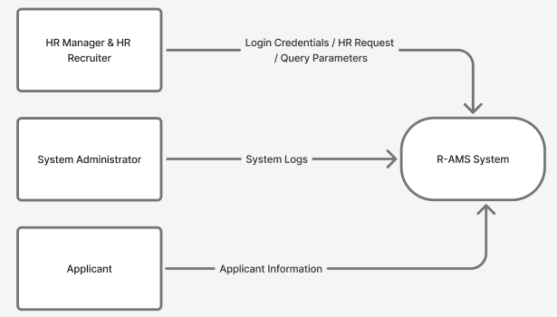
Figure 3: Context Diagram of a developed Web-based R-AMS
Figure 3 shows the Context Diagram for R-AMS, highlighting the interaction between Applicants, HR Recruiters, HR Managers, System Administrators, and the centralized database. Applicants submit their information through the web form, while HR personnel authenticate through the HR dashboard to view, update, and manage applicant records based on their assigned roles.
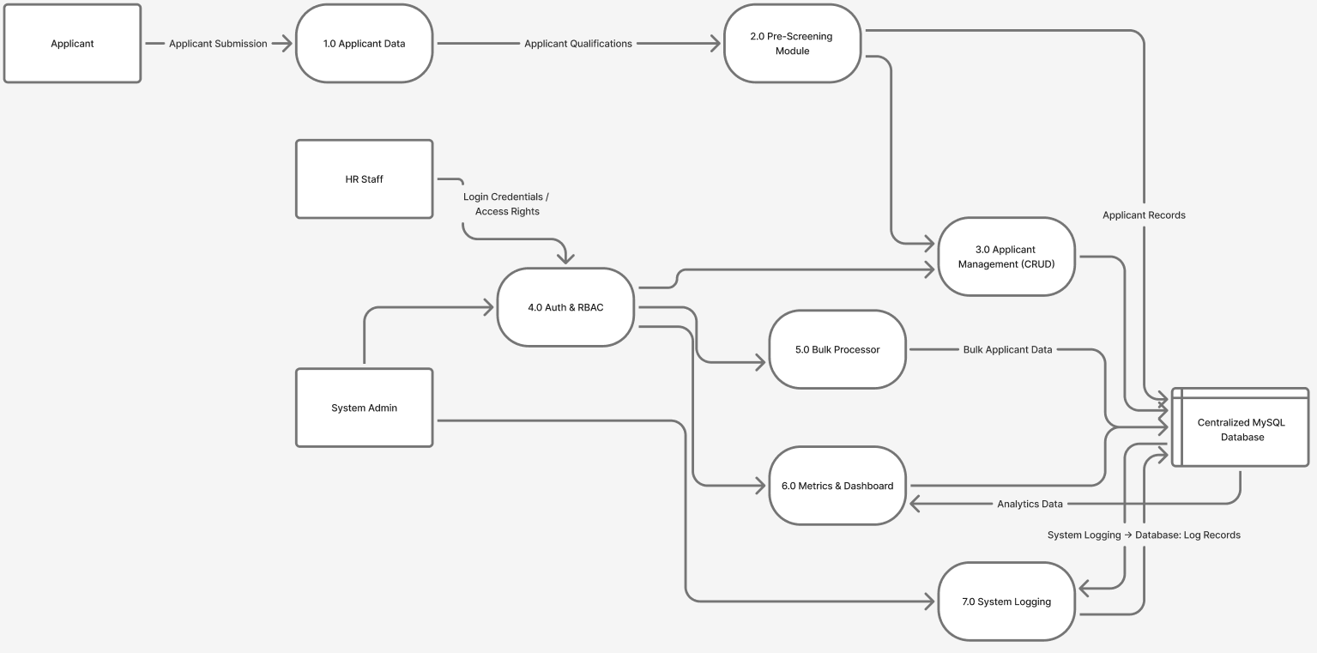
Figure 4: Top level Data Flow Diagram for the development of Web-based R-AMS
Figure 4 presents the Top-Level Data Flow Diagram, detailing key system processes such as login authentication, applicant data submission, CRUD operations, bulk upload processing, dashboard analytics, and system logging. These diagrams demonstrate how the system routes information—from the initial data entry point, through validation and storage, up to the administrative functions that manage and analyze recruitment data.
Together, these diagrams define the structural and operational design of the R-AMS, showing how users access system modules, how data is processed internally, and how each component integrates to support a streamlined and secure recruitment workflow.

Software Design
The Software Design of the Recruitment and Applicant Management System (R-AMS) presents the system's structural and behavioral components, focusing on user interactions, main services, and their permissions(figure 5). The design centers on a Use Case Diagram that identifies the actors and primary actions the system supports. These diagrams and descriptions guide development and clarify how responsibilities are separated between the applicant-facing interface and the HR administration dashboard.
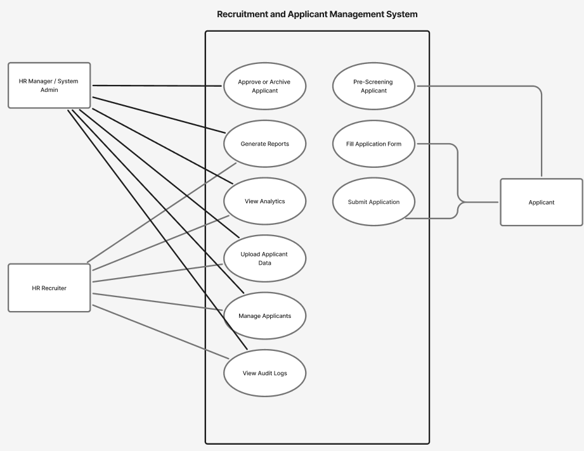
Figure 5: Software design interaction and use cases for R-AMS.

Database Design

The information maintained in the system is illustrated using the MySQL RDBMS (Relational Database Management System) in Figure 6 to 7. The RDBMS shows the data of the following: applicant, hr user, and module.
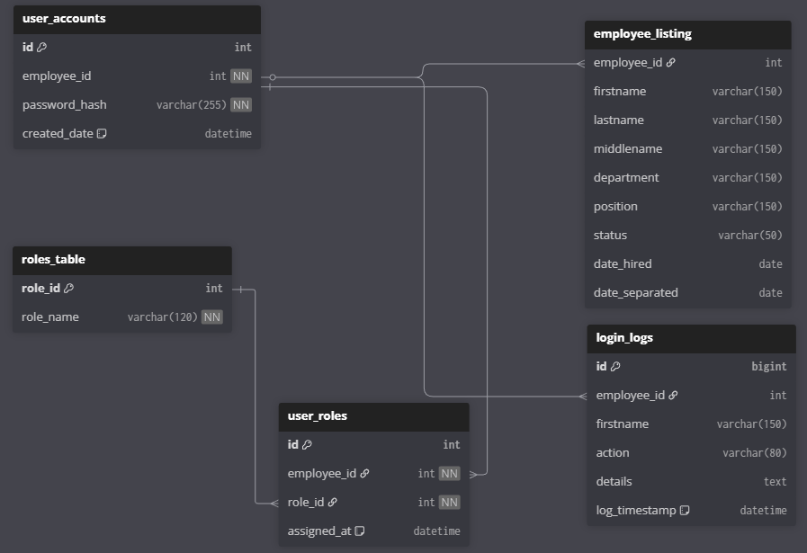

Figure 6: HR User Login, Role permission, Logs Database design for R-AMS

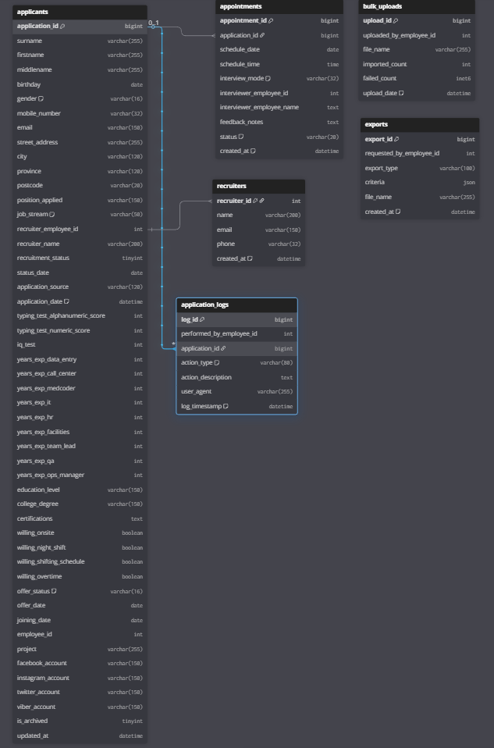 Figure 7: Applicant database design for R-AMS

System architecture
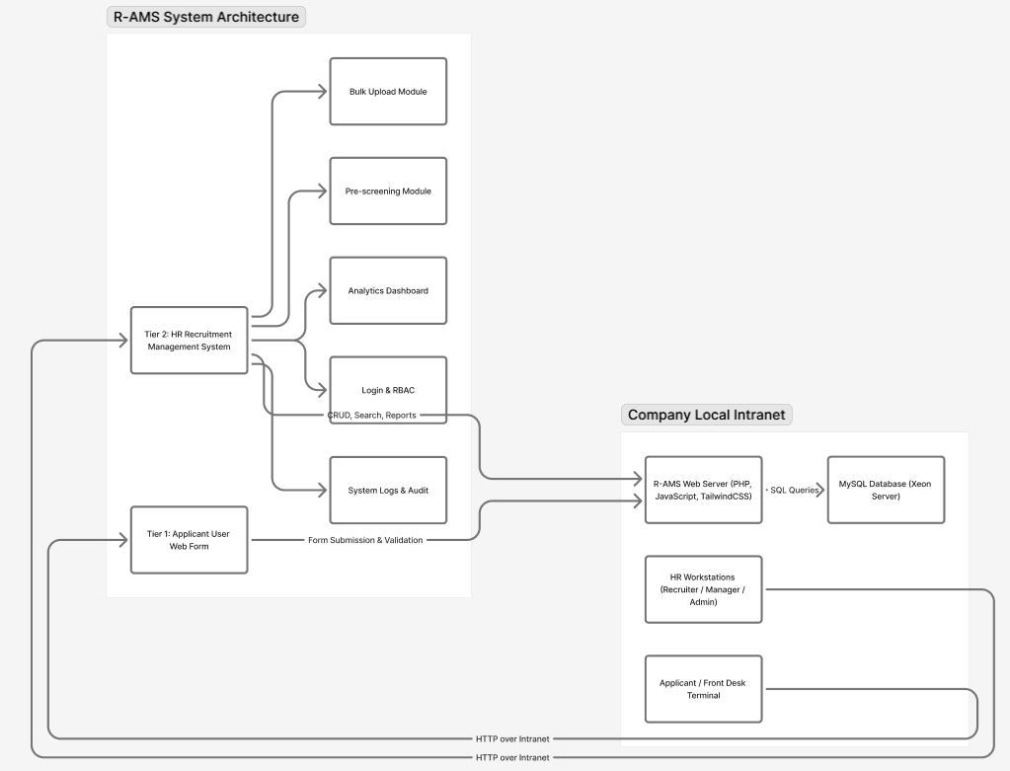
The System Architecture Diagram which displays the communication interface of the system for both the Applicant, HR user and local server.
Figure 8: System Architecture Diagram for R-AMS

Desktop UI
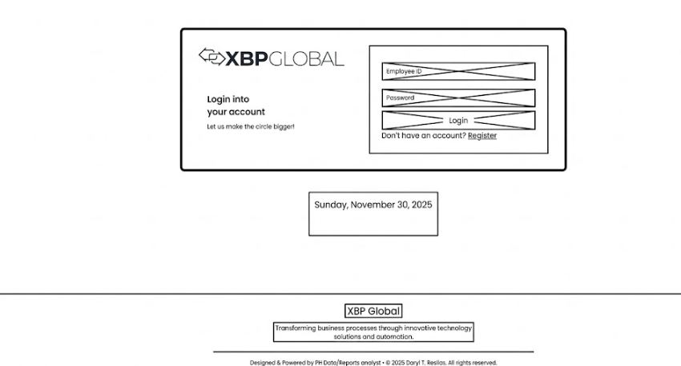
Figure 9: Login on R-AMS

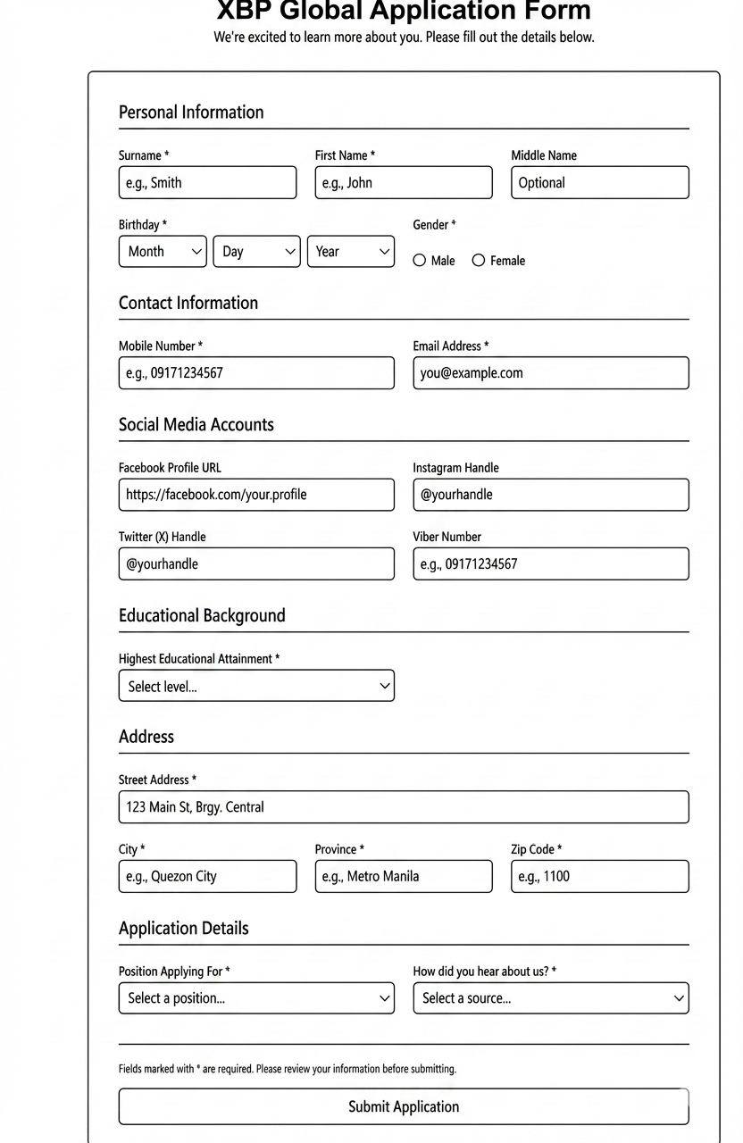
Figure 10: Tier-1 Applicant Form
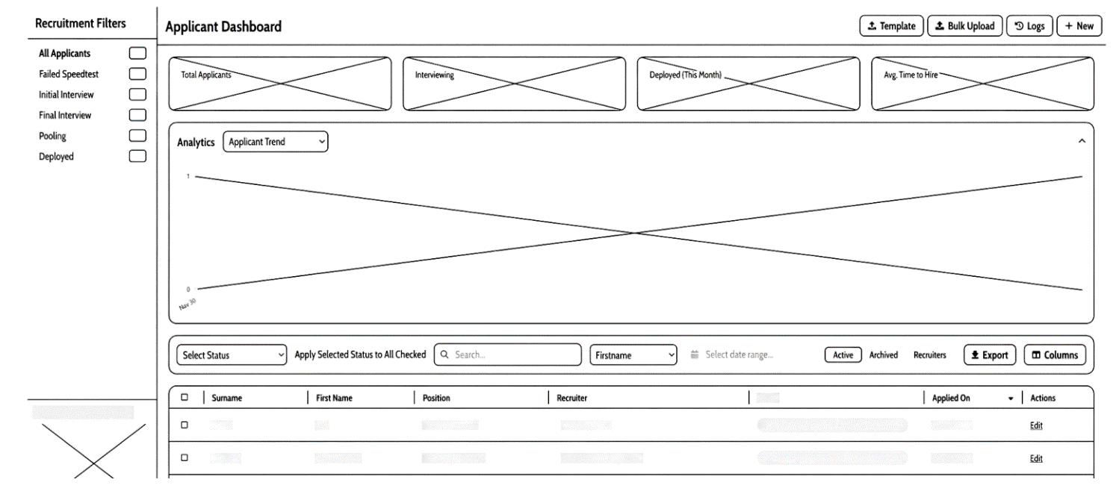
Figure 11: Tier-2 Dashboard Recruitment Active view

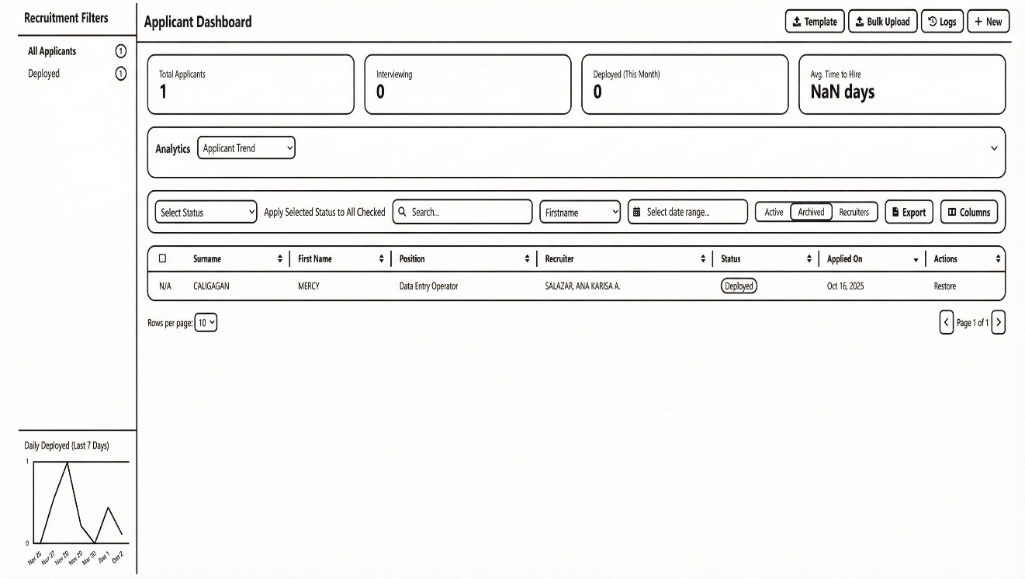
Figure 12: Tier-2 Dashboard Recruitment Active Archived/Restore (chart hidden)

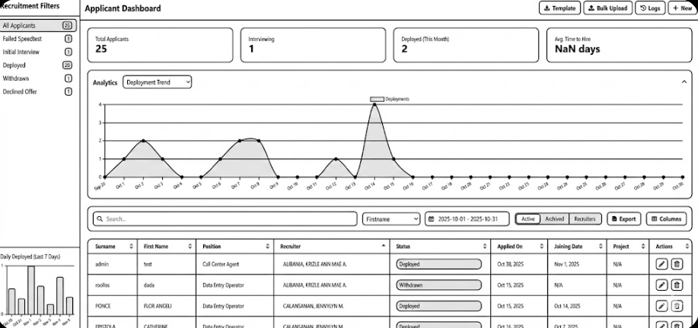
Figure 13: Tier-2 Dashboard Recruitment Active table values

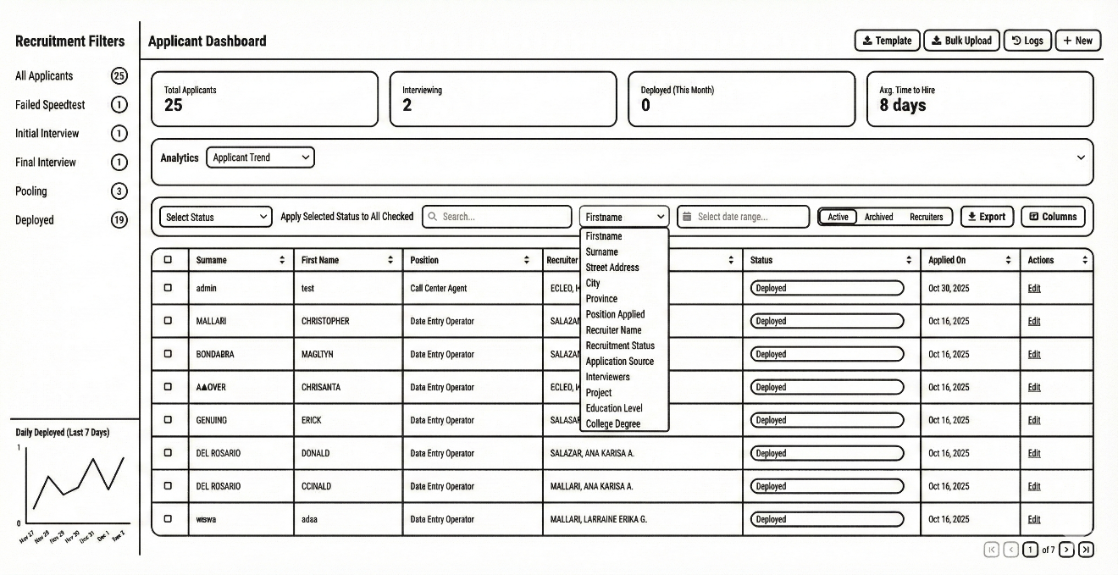
Figure 14: Tier-2 Dashboard Recruitment Active with Table values and search Option dropdown (Chart hidden)

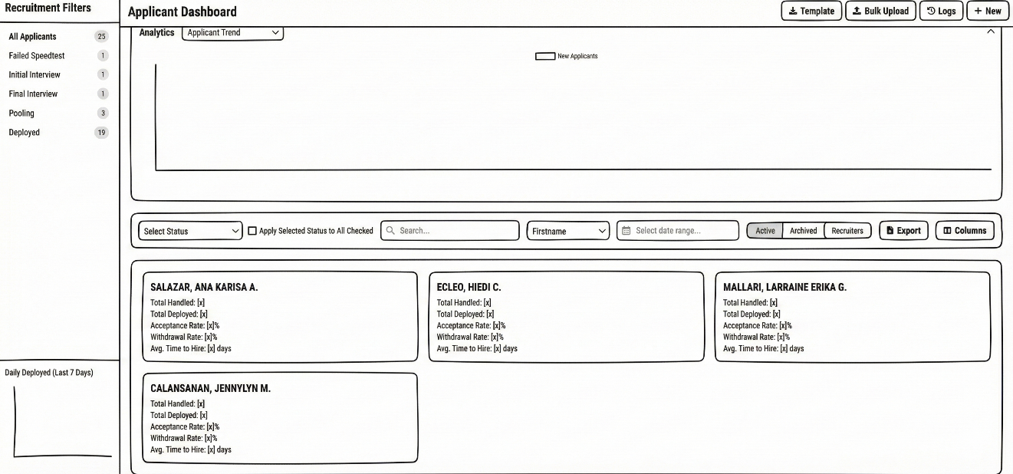
Figure 15: Tier-2 Dashboard Recruitment Recruiter KPI cards

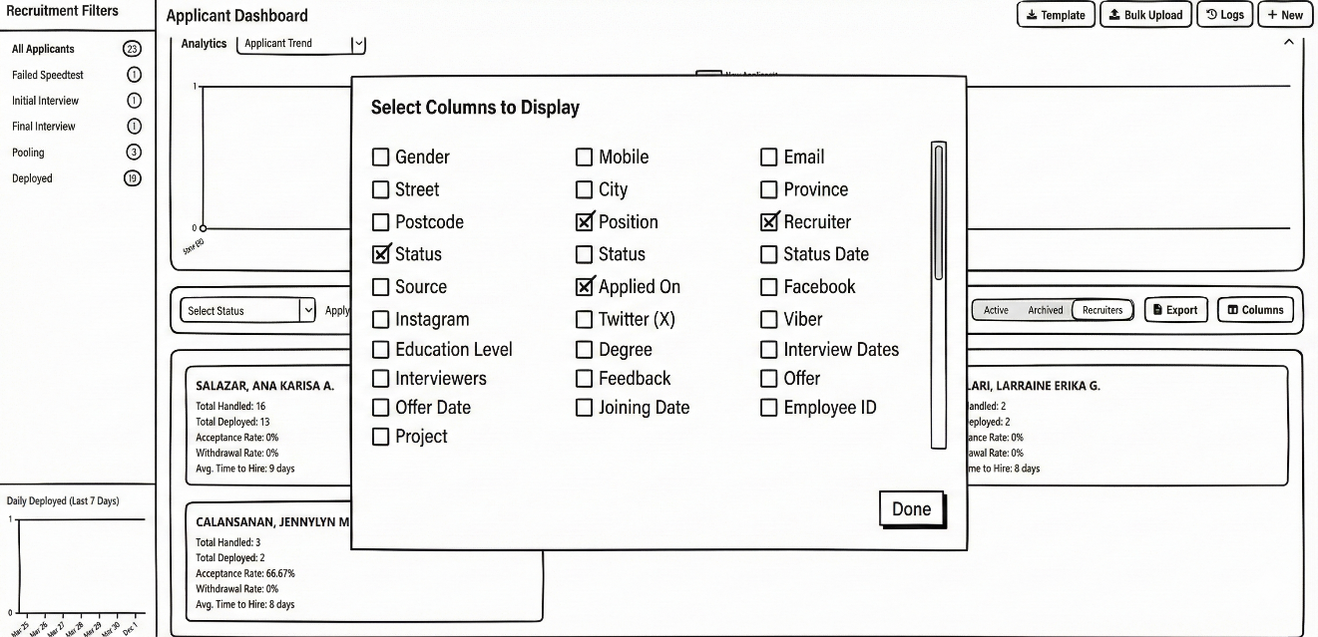
Figure 16: Tier-2 Dashboard Recruitment Column Selection to display
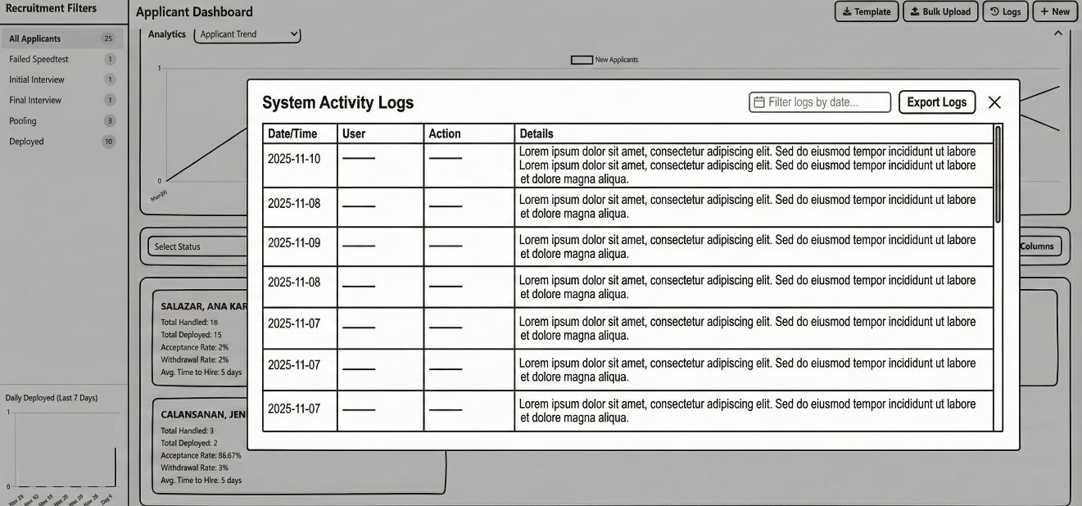
Figure 17: Tier-2 Dashboard Recruitment Activity Logs

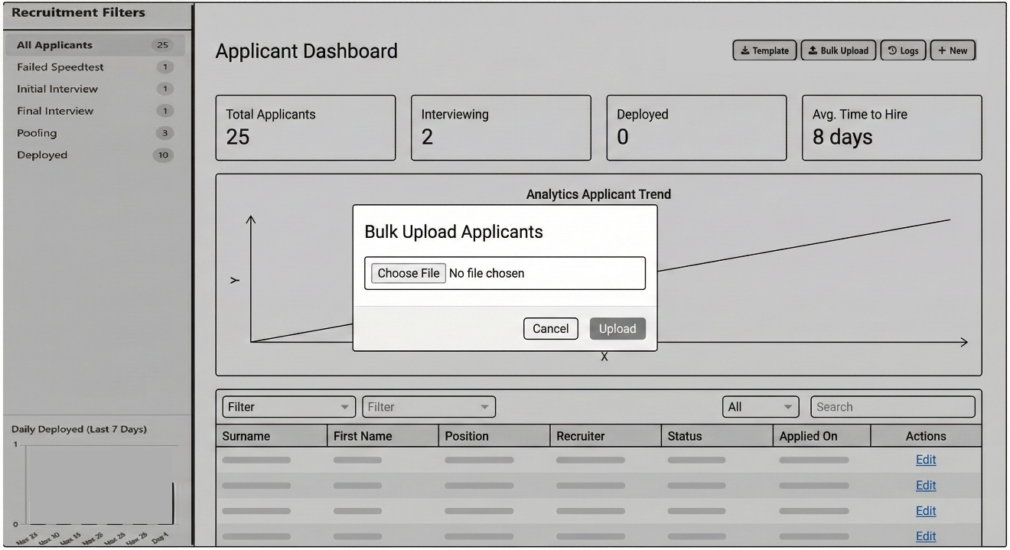
Figure 18: Tier-2 Dashboard Recruitment Bulk Upload Applicants

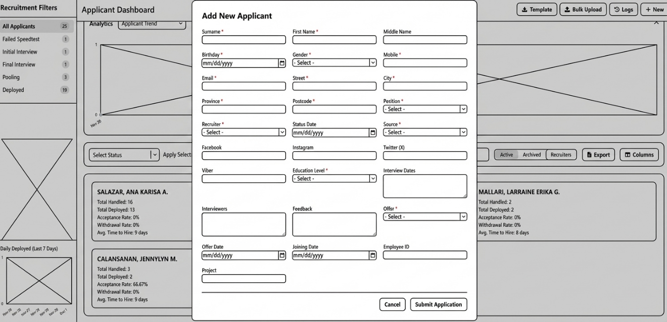
Figure 19: Tier-2 Dashboard Recruitment Add Single New Applicant

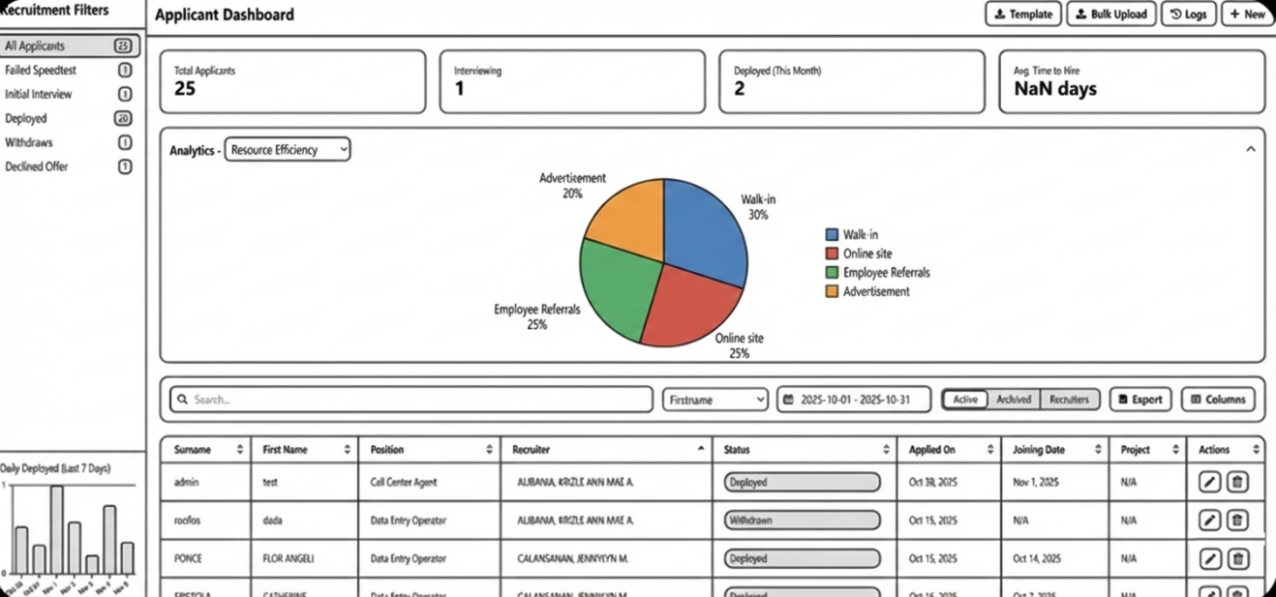
Figure 20: Tier-2 Dashboard Recruitment Analytics = Resource Efficiency


Figure 21: Tier-2 Dashboard Recruitment Analytics = Deployment Trend

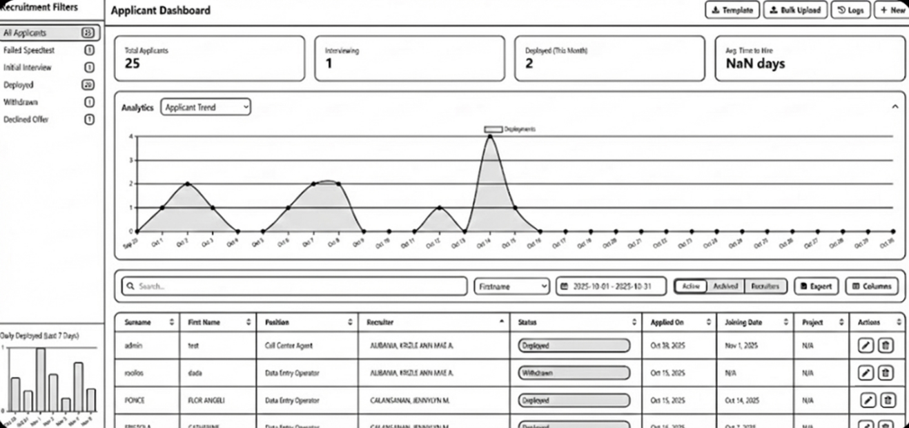
Figure 22: Tier-2 Dashboard Recruitment Analytics = Applicant Trend

Project Development
The Recruitment and Applicant Management System (R-AMS) will be developed using the Iterative Waterfall Model, which allows continuous feedback between phases to improve system quality and correctness. The model consists of Requirement Analysis, System Design, Implementation, Testing, Deployment, and Maintenance, as shown in Figure 23.
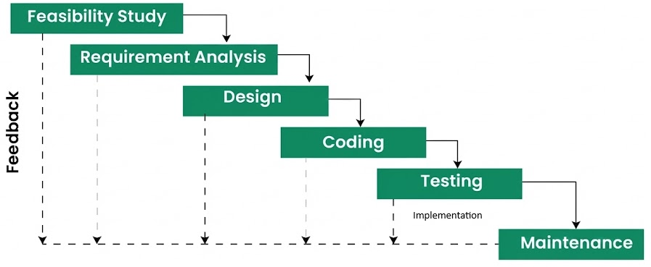
Figure 23: Iterative Waterfall Model

Feasibility Study
This phase evaluated the technical, operational, and organizational feasibility of developing R-AMS. This assessed the availability of required technologies, compatibility with the company’s intranet environment, and the readiness of HR users to adopt a web-based recruitment system.

Requirement Analysis
In this phase, the functional and non-functional requirements of the R-AMS were identified. Existing recruitment workflows were analyzed, and system requirements such as applicant data capture, role-based access control, dashboards, security, and reporting were defined.

Design
The Design phase translated the requirements into system architecture and interface specifications. This included the two-tier system structure, database design, data flow diagrams, and user interface layouts for both the applicant form and HR dashboard.

Coding
During the Coding phase, the system will be developed based on the approved design using PHP, JavaScript, HTML, TailwindCSS, CSS, and MySQL. Core modules such as applicant submission, CRUD operations, bulk upload, analytics, and authentication were implemented.

Testing
This phase involved testing the system to ensure correctness, usability, performance, and security. Bugs and issues identified during testing were corrected iteratively, guided by ISO/IEC 25010 software quality standards.

Maintenance
The Maintenance phase ensures the continued reliability and usability of the R-AMS. It includes bug fixes, system updates, performance optimization, and minor enhancements based on user feedback.

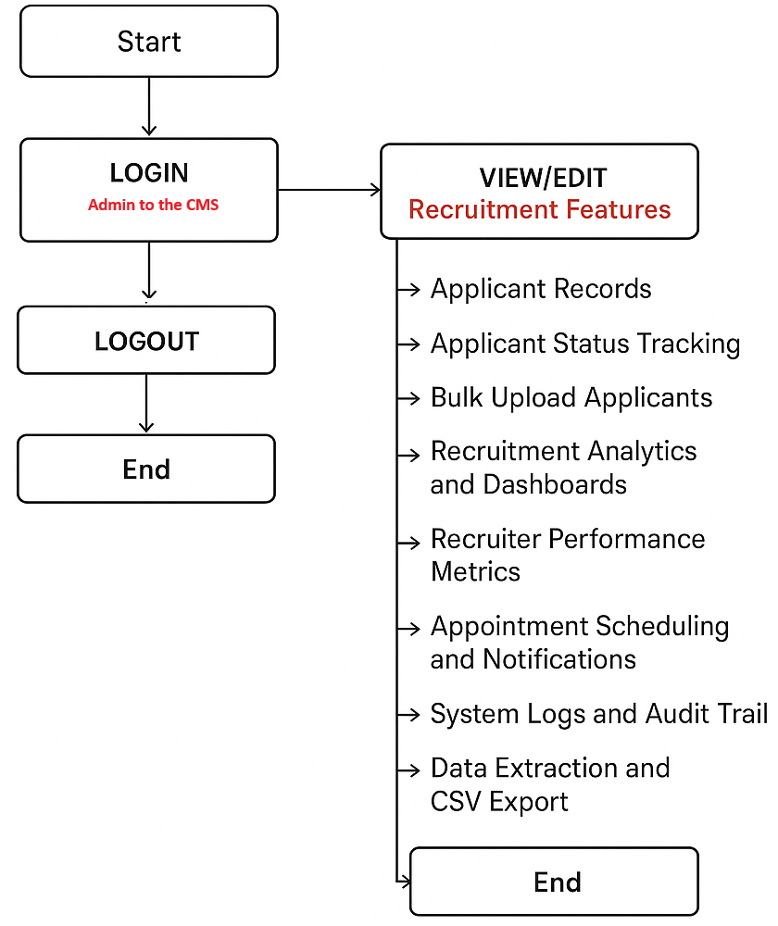
Operation and Testing Procedure

Figure 24: CMS HR Administrator Flowchart

CMS Administrator (R-AMS)
- On the web browser, type the address (URL) of the Recruitment and Applicant Management System (R-AMS) – Tier 2. (Figure 24)
- Enter the administrator username and password to access the system.
- Browse the HR dashboard after successful authentication.
- View or manage the following system features:
  - Applicant records (create, view, update, archive)
  - Applicant status tracking (pre-screened, interviewed, deployed, archived etc.)
  - Bulk upload of applicant data (CSV import)
  - Recruitment analytics and dashboards
  - Recruiter performance metrics
  - Appointment scheduling and notifications
  - System logs and audit trail
- After completing the required tasks, log out of the system.
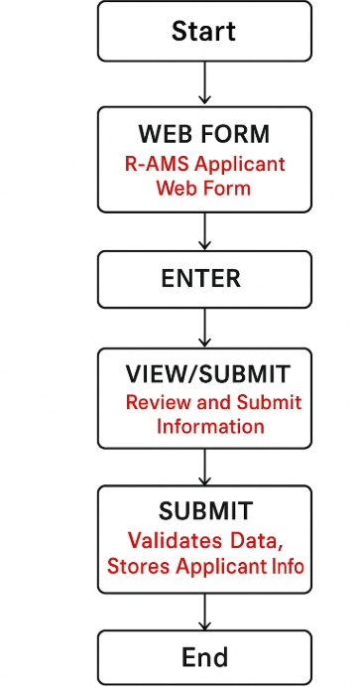
Figure 25: Applicant Flowchart

Applicant
- On a desktop workstation within the company premises, the applicant accesses the R-AMS Applicant Web Form(Tier-1) through a web browser. (Figure 25)
- The applicant fills in the required information such as personal details, contact information, educational background, skills, and other required fields.
- The applicant reviews the entered information to ensure accuracy and completeness.
- The applicant submits the application form.
- The system validates the data and securely stores the applicant information in the centralized database.
- The application process ends, and the applicant waits for further communication from the HR department.

Functional Testing
This shall be conducted to verify that all features and functionalities of the (R-AMS) operate according to their specified requirements. This testing ensures that each system module produces the expected output based on defined inputs.
For each development iteration, the following steps were performed:
- Identify the functions included in each software build.
- Prepare test input data based on functional specifications.
- Identify the expected output based on system requirements.
- Execute the defined test cases.
- Compare the actual results with the expected outcome.
- Determine the post condition of the system after execution.
- Evaluate the test case if passes or fails.
The following tables present the functional testing procedures conducted to verify system correctness, portability, and usability.

Portability Testing Procedure

Table 1:

Test Case | Test Environment | Steps Undertaken | Type
Homepage loads correctly | Firefox, Chrome, Edge, Safari | 1. Open browser  2. Enter R-AMS URL | Co-existence
Login page access | Firefox, Chrome, Edge, Safari | 1. Open browser  2. Navigate to login page | Co-existence
Applicant Web Form access | Firefox, Chrome, Edge, Safari | 1. Open applicant form URL  2. Load form | Co-existence
Applicant submission | Firefox, Chrome, Edge, Safari | 1. Fill out form  2. Click Submit | Co-existence
HR Dashboard access | Firefox, Chrome, Edge, Safari | 1. Login as HR user  2. Load dashboard | Co-existence
Applicant Records (CRUD) | Firefox, Chrome, Edge, Safari | 1. View applicant list  2. Create/Edit/Archive record | Co-existence
Bulk Upload (CSV) | Firefox, Chrome, Edge, Safari | 1. Upload CSV file  2. Validate data | Co-existence
Analytics Dashboard | Firefox, Chrome, Edge, Safari | 1. Open analytics module  2. View charts | Co-existence
System Logs | Firefox, Chrome, Edge, Safari | 1. Open logs module  2. View activity logs | Co-existence
CSV Export | Firefox, Chrome, Edge, Safari | 1. Select records  2. Export CSV | Co-existence

Compatibility Testing
Compatibility testing will be conducted to ensure that the R-AMS operates consistently across different devices, operating systems, and browsers. This test verifies that the system produces the same output under varying environments. Please note that R-AMS will not have Mobile set-up since it requires company intranet to access.
The following steps were followed:
- Execute the system on different devices and environments (Desktop/Laptops).
- Observe system behavior and record any failures.
- Compare outputs across platforms to ensure consistency.

Compatibility Testing Procedure
Table 2
Test Case | Browser | Steps Undertaken | Type
Access R-AMS Dashboard | Chrome | Open intranet URL and login | Co-existence
Access R-AMS Dashboard | Edge | Open intranet URL and login | Co-existence
Access R-AMS Dashboard | Firefox | Open intranet URL and login | Co-existence
Access Recruitment Modules | Chrome/Edge/Firefox | Navigate applicant records, dashboards, logs | Co-existence

Usability Testing
Usability testing will be conducted to ensure that the R-AMS provides an intuitive, user-friendly, and accessible interface for both applicants and HR personnel. This test evaluates ease of navigation, clarity of content, and overall user experience.
The following steps were performed:
- Execute the system across multiple browsers and workstation.
- Observe user interaction and task completion.
- Identify usability issues affecting navigation or comprehension.
Usability Testing Procedure
Table 3
Test Case | Steps Taken | Expected Output | Type
Easy navigation | 1. Open homepage  2. Navigate modules | Sections accessible within 1–2 clicks | User Interface
Clear content display | 1. Open forms/pages  2. Review text | Text is readable and structured | Operability
Intuitive layout | 1. Browse dashboard | Menus and buttons are easily identifiable | UI Aesthetics
Applicant form usability | 1. Fill form  2. Submit | Form is easy to complete | Accessibility

Evaluation Procedure
The evaluation of the R-AMS was conducted using descriptive and quantitative methods. A 4-Point Likert Scale was utilized to assess the system’s acceptability based on ISO/IEC 25010 quality criteria.
The following procedure was followed to evaluate the acceptability of the developed system application:
- Selected HR personnel and system users as evaluator-respondents.
- Demonstrated the R-AMS and explained its modules and features.
- Allowed evaluators to use and explore the system.
- Evaluators rated the system using the ISO/IEC 25010 criteria.
- Once demonstration completed, the evaluator respondents were given a questionnaire.
- Tabulated results using Microsoft Excel.
- Interpreted results using the numerical rating scale.

Table 4
4-Point Likert Scale
Numerical Rating | Adjectival Rating
4 | Highly Acceptable
3 | Very Acceptable
2 | Acceptable
1 | Not Acceptable

